ISUZU MOTOR

RT50 PaintShop ASM Line
Paint Shop Instruction System
(PSIS)

SETUP MANUAL

OMRON

TABLE OF CONTENTS

1. Add User for SQL Server 2008 (PSIS User) 3
2. Restore Database from Backup file (.bak) 8
3. PAINT-SERVER installation 12
4. PAINT-CLIENT Installation 15
5. Modify Host File of Window 18

TABLE OF FIGURES

Figure 1 Show selection of SQL Server Management Studio 4
Figure 2 Connect to Server Screen of SQL Server 2008 4
Figure 3 Add New Login (SQL Server 2008) screen 5
Figure 4 New Login input Screen 6
Figure 5 Set Server Roles for New Login input Screen 7
Figure 6 New Login user added (psisuser) 7
Figure 7 Show select Restore Database of SQL Server 2008 8
Figure 8 Restore Database Screen of SQL Server 2008 9
Figure 9 Select Database Backup File for Restore 9
Figure 10 Select Database Backup File for Restore (2) 10
Figure 11 Restore Database Screen after select backup file already 10
Figure 12 Select Options to Restore Database 11
Figure 13 Pop-Up Message Restore Database Completed 11
Figure 14 PAINT-SERVER Setup icon 12
Figure 15 Setup Wizard Screen PAINT-SERVER 12
Figure 16 Select Installation Folder Screen PAINT-SERVER 13
Figure 17 Confirm Installation Screen PAINT-SERVER 13
Figure 18 Installing Process Screen PAINT-SERVER 14
Figure 19 Installations Complete Screen PAINT-SERVER 14
Figure 14 PAINT-SERVER Setup icon 15
Figure 15 Setup Wizard Screen PAINT-SERVER 15
Figure 16 Select Installation Folder Screen PAINT-SERVER 16
Figure 17 Confirm Installation Screen PAINT-SERVER 16
Figure 18 Installing Process Screen PAINT-SERVER 17
Figure 19 Installations Complete Screen PAINT-SERVER 17
Figure 20 Directory of host file 18
Figure 21 Open host file 18
Figure 22 Select text editor program 19
Figure 23 Add new ip address and host name mapping 20
Figure 24 Save host file 21

1. Add User for SQL Server 2008 (PSIS User)

Open SQL Server Management Studio program by click Start -> Program -> Microsoft SQL Server 2008 -> SQL Server Management Studio.
After that will show Connect to Server screen, input as below values
- Server type : Database Engine
- Server name : PSIS-SERVER\SQL2008EXPRESS
- Authentication : SQL Server Authentication
- User name : sa
- Password : …
Click Connect button, will show SQL Server Management Studio screen

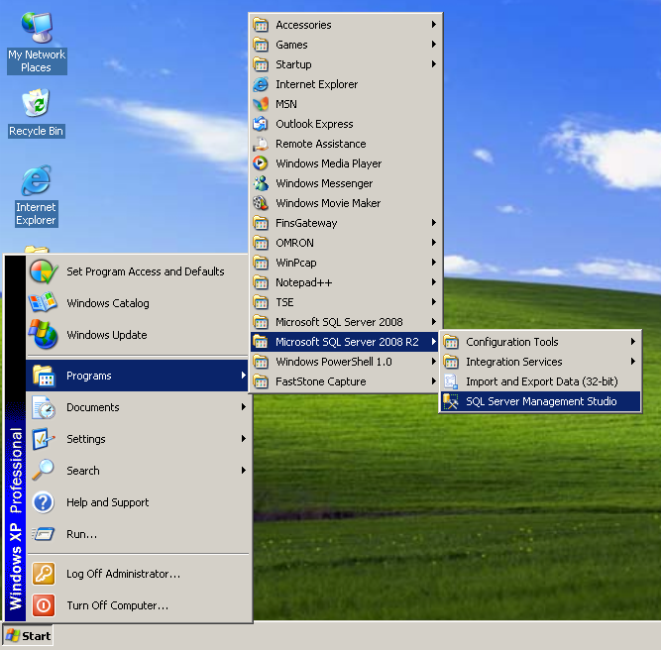
Figure 1 Show selection of SQL Server Management Studio
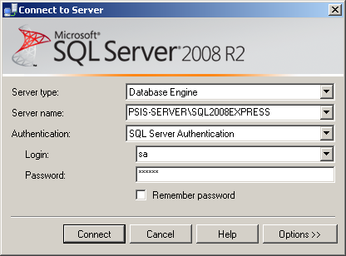
Figure 2 Connect to Server Screen of SQL Server 2008

Right click at “Login” and select “New Login…”

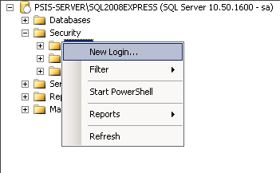
Figure 3 Add New Login (SQL Server 2008) screen

Input as following figures.
- User: psisuser
- Password: 36a2c3

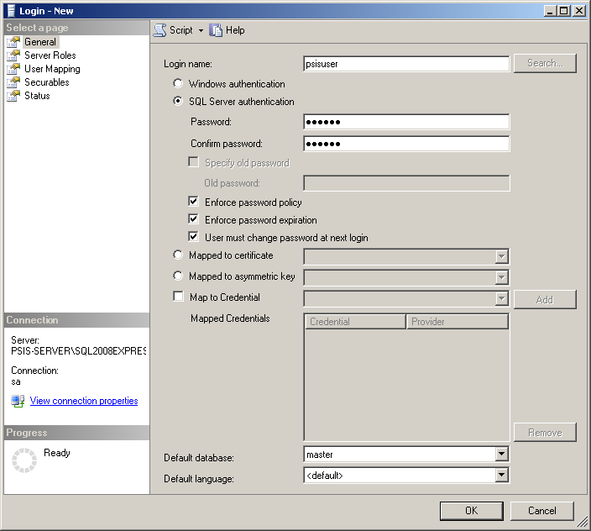
Figure 4 New Login input Screen
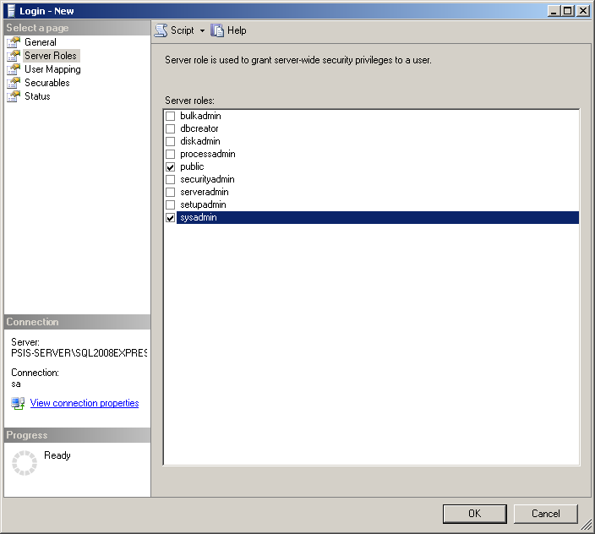
Figure 5 Set Server Roles for New Login input Screen

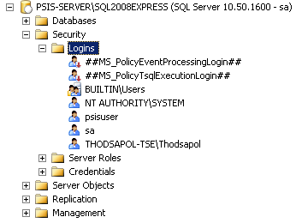
Figure 6 New Login user added (psisuser)

2. Restore Database from Backup file (.bak)

Open program SQL Server 2008 and Connect to Server. It will show SQL Server Management Studio.
Select Database to Restore Right click and select Task -> Restore -> Database…

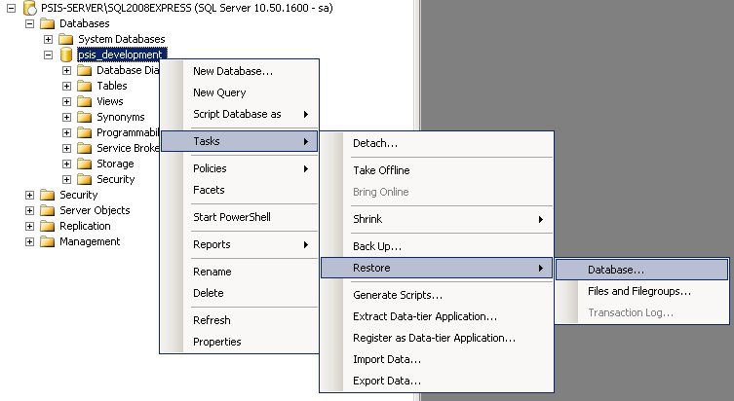
Figure 7 Show select Restore Database of SQL Server 2008
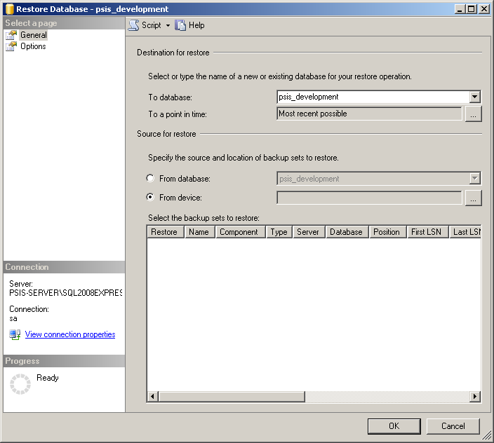
Figure 8 Restore Database Screen of SQL Server 2008

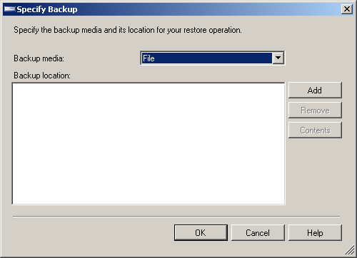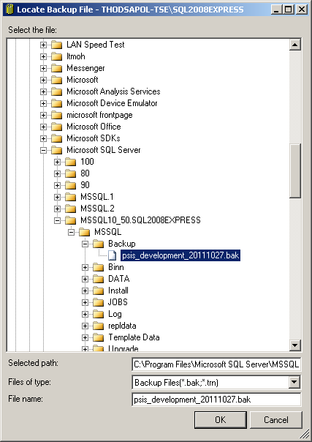
Figure 9 Select Database Backup File for Restore
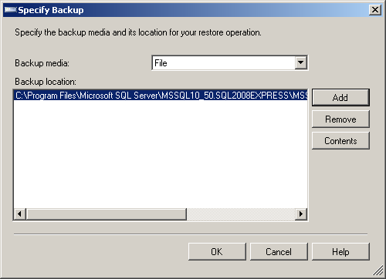
Figure 10 Select Database Backup File for Restore (2)

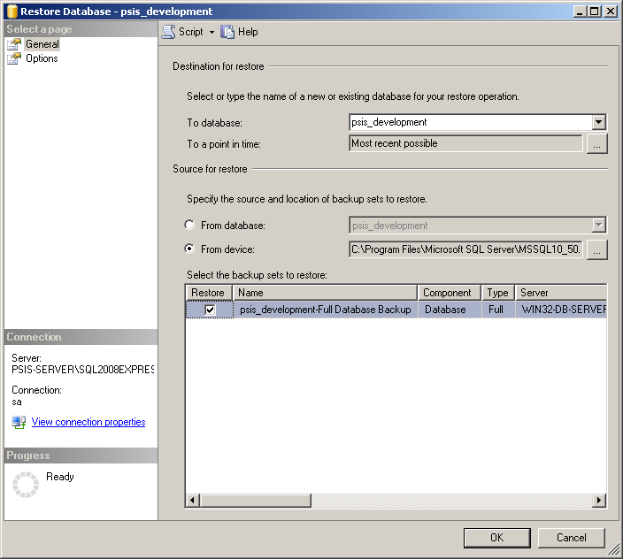
Figure 11 Restore Database Screen after select backup file already
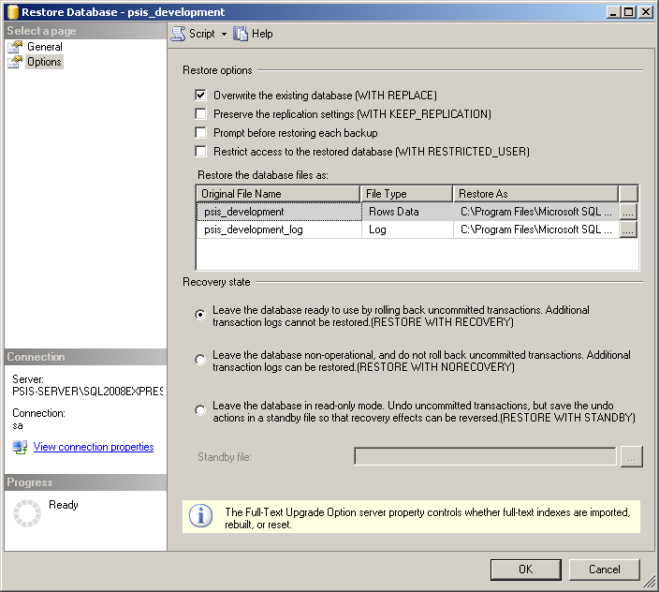
Figure 12 Select Options to Restore Database

Click OK button to start Restore Database, when finished Pop-Up Message show “The restore of database ‘psis_development’ completed successfully.” click OK to complete Restore Database process.

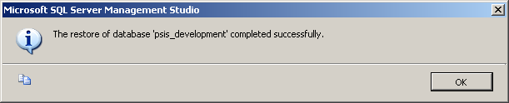
Figure 13 Pop-Up Message Restore Database Completed

3. PAINT-SERVER installation

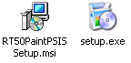
Figure 14 PAINT-SERVER Setup icon

PAINT-SREVER Installation
- Open Folder “SETUP\PAINT-SERVER” from CD, run Setup.exe will show Setup Wizard screen, press Next button.
- At Select Installation Folder screen, select “Just Me” and press Next button.
- At Confirm Installation screen, press Next button.
- Installing process until Installation Complete, press Close button to finish installation.

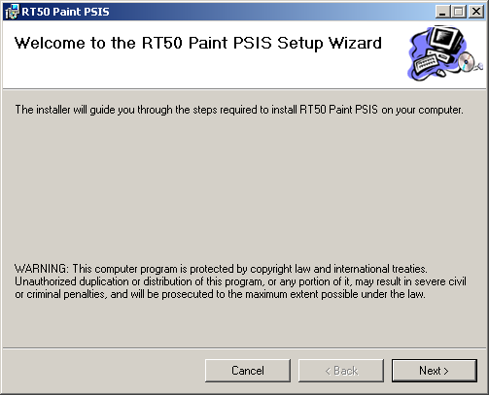
Figure 15 Setup Wizard Screen PAINT-SERVER
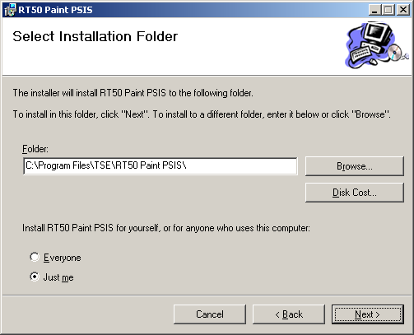
Figure 16 Select Installation Folder Screen of PAINT-SERVER

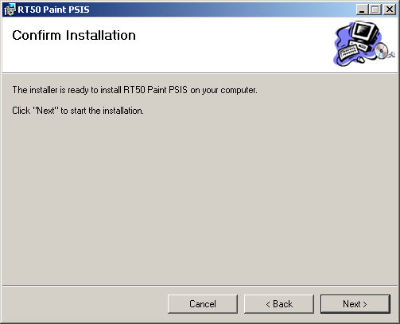
Figure 17 Confirm Installation Screen of PAINT-SERVER
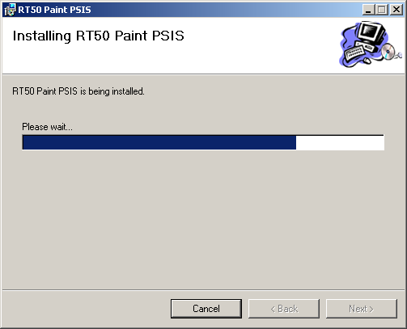
Figure 18 Installing Process Screen of PAINT-SERVER

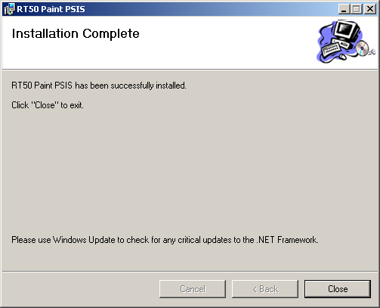
Figure 19 Installations Complete Screen of PAINT-SERVER

4. PAINT-CLIENT Installation

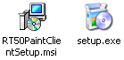
Figure 20 PAINT-CLIENT Setup icon

PAINT-CLIENT Installation
- Open Folder “SETUP\PAINT-CLIENT” from CD, run Setup.exe will show Setup Wizard screen, press Next button.
- At Select Installation Folder screen, select “Everyone” and press Next button.
- At Confirm Installation screen, press Next button.
- Installing process until Installation Complete, press Close button to finish installation.

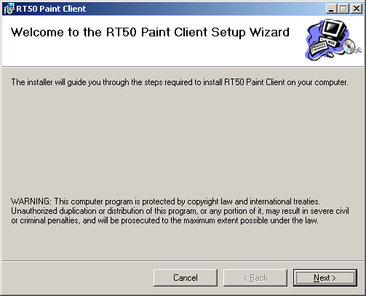
Figure 21 Setup Wizard Screen PAINT-CLIENT
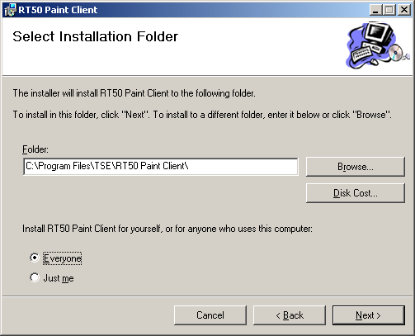
Figure 22 Select Installation Folder Screen of PAINT-CLIENT

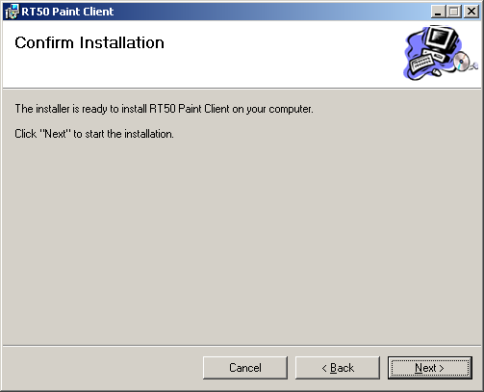
Figure 23 Confirm Installation Screen PAINT-CLIENT
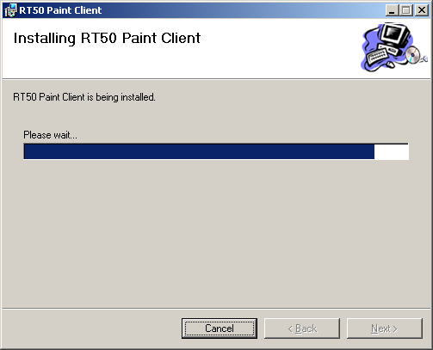
Figure 24 Installing Process Screen PAINT-CLIENT

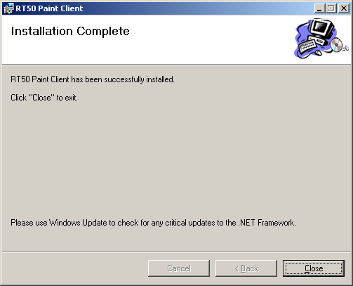
Figure 25 Installations Complete Screen PAINT-CLIENT

5. Modify Host File of Window

Modify host file
- Open Folder “C:\WINDOWS\system32\drivers\etc”, right click on hosts file, then select open, Open with screen will be shown.

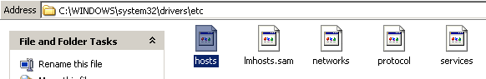

Figure 26 Directory of host file

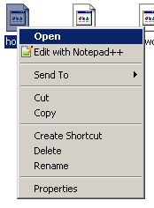
Figure 27 Open host file

- At Open with screen, select notepad program, then press OK button.
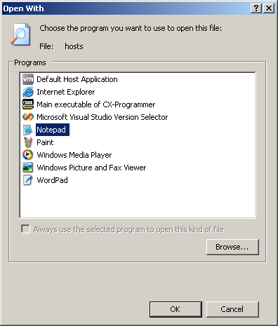
Figure 28 Select text editor program

- At notepad screen, add new value of ip address and host name at the end of file
Paint server IP address: x.x.x.x
Paint server Host name: PSIS-SERVER
Example: 192.168.1.29 PSIS-SERVER

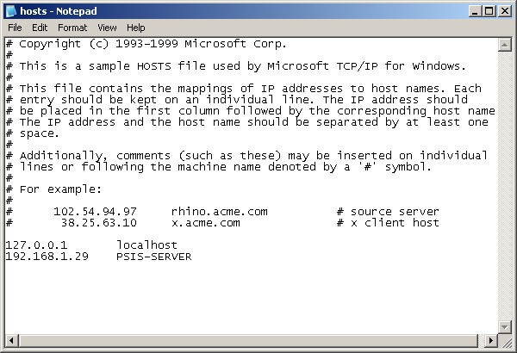
Figure 29 Add new ip address and host name mapping

- Save file by click File -> Save
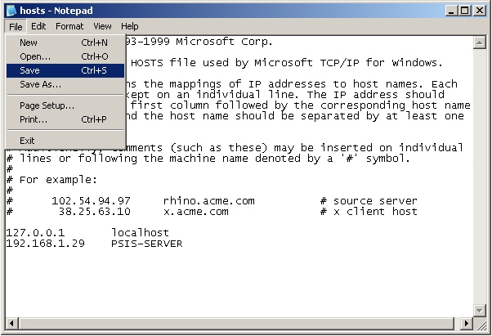
Figure 30 Save host file

- Close text editor program

